**DESCRIPTION**

Deluxe sprinkle mix containing nonpareils.

**INGREDIENTS**

Carnauba wax, citric acid, dextrin, glucose, glucose powder, glycerin, gum Arabic, magnesium silicate, sugar, tapioca starch, red 3 (e127), blue 1 (e133), red 40 (e129), yellow 5 (e102), yellow 6 (e110), and less that 1/10 of 1% sodium benzoate

**SENSORY SPECIFICATIONS**

Color(s): Red, Warm Yellow, Orange, Burgundy, Green.

Flavor: Sweet Vanilla

Texture: Crunchy

**NUTRITION FACTS**

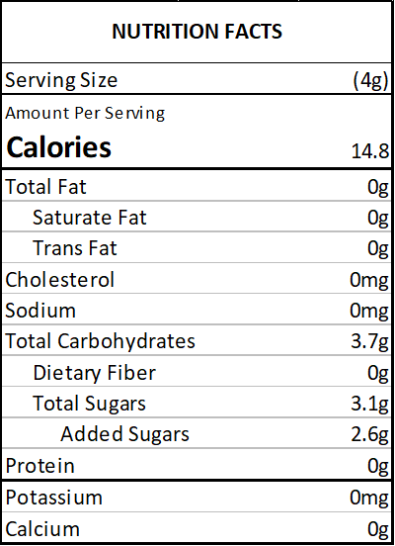

**ALLERGENS**

No major allergens present.

(This list is not intended to address all substances that may represent an allergen risk to certain individuals.) This product is prepared and packaged using machines that may come into contact with WHEAT, EGGS, MILK, SOY, and TREE NUTS. Unintentional cross contamination can always be a possibility, however remote.

**PACKING**

2 oz Bag (Net Vol. 1/4 Cup) - clear standup barrier pouch

4 oz Bottle (Net Vol. 1/2 Cup) - clear PET plastic jar with white lid

8 oz Bottle (Net Vol. 1 Cup) - clear PET plastic jar with white lid

1 lb Bulk Bag - clear standup barrier pouch

5 lb Bulk Bag - clear standup barrier pouch

10 lb Bulk Bag - corrugated carton containing 1 clear poly bag

**USE**

Decorating cakes, cookies, doughnuts, ice cream, pies and sweets in general.

**STORAGE**

Store in a cool, dry place. Avoid high temperatures, humidity, sunlight exposure, chemicals and strong odors.

**SHELF LIFE**

18 months from the date of manufacture, under the correct storage conditions.

**KOSHER CERTIFICATIONS**

Not certified.

**COUNTRY OF ORIGIN**

United States: nonpareils