**DESCRIPTION**

Metallic sprinkle mix containing decorettes, candy pearls/sixlets, dragees, wafer pieces.

**INGREDIENTS**

Acetic acid, beeswax, calcium stearate, carnauba wax, cocoa, confectioner's glaze, corn starch, corn syrup, dextrin, dextrose, gelatin (FISH), HPMC, hydrogenated palm kernel oil, lecithin (SOY), maltodextrin, mica based pearlescent pigment, propylene glycol, reduced protein whey (MILK), salt, sugar, tapioca dextrin, blue 1 (e133), blue 2 (e132), red 40 (e129), silver (e174), titanium dioxide (e171), yellow 5 (e102) , yellow 6 (e110), natural & artificial flavors.

**SENSORY SPECIFICATIONS**

Color(s): Dark Green, Gold, Vintage Gold.

Flavor: Sweet Vanilla

Texture: Crunchy

**NUTRITION FACTS**

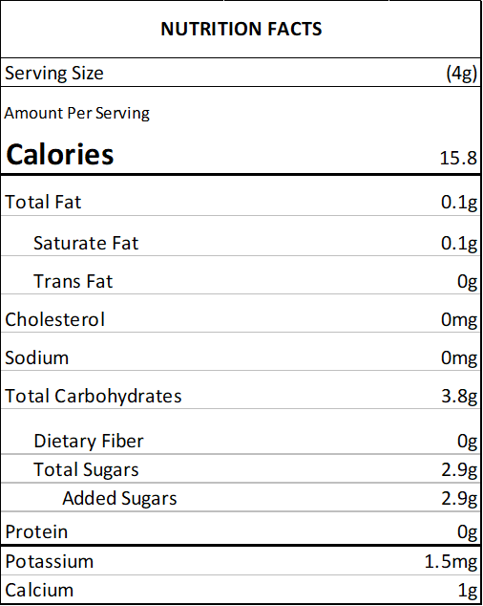

**ALLERGENS**

SOY, MILK, FISH, WHEAT

(This list is not intended to address all substances that may represent an allergen risk to certain individuals.) This product is prepared and packaged using machines that may come into contact with WHEAT, EGGS, MILK, SOY, and TREE NUTS. Unintentional cross contamination can always be a possibility, however remote.

**PACKING**

2 oz Bag (Net Vol. 1/4 Cup) - clear standup barrier pouch

4 oz Bottle (Net Vol. 1/2 Cup) - clear PET plastic jar with white lid

8 oz Bottle (Net Vol. 1 Cup) - clear PET plastic jar with white lid

1 lb Bulk Bag - clear standup barrier pouch

5 lb Bulk Bag - clear standup barrier pouch

10 lb Bulk Bag - corrugated carton containing 1 clear poly bag

**USE**

Decorating cakes, cookies, doughnuts, ice cream, pies and sweets in general.

**STORAGE**

Store in a cool, dry place. Avoid high temperatures, humidity, sunlight exposure, chemicals and strong odors.

**SHELF LIFE**

18 months from the date of manufacture, under the correct storage conditions.

**KOSHER CERTIFICATIONS**

Not certified.

**COUNTRY OF ORIGIN**

United States: decorettes, dragees, wafer pieces

Canada: candy pearls/sixlets