**DESCRIPTION**

Metallic sprinkle mix containing decorettes, nonpareils, sixlets, candy pearls, round dragees, confetti/quins, wafer paper.

**INGREDIENTS**

Acetic acid, beeswax, calcium stearate, carnauba wax, carrageenan, cellulose gum, citric acid, cocoa, confectioner's glaze, corn starch, corn syrup, dextrin, dextrose, gelatin (FISH), glucose powder, glycerin, gum Arabic, HPMC, hydrogenated palm kernel oil, lecithin (SOY), magnesium silicate, maltodextrin, mica based pearlescent pigment, mono & diglycerides, polysorbate 60, potassium sorbate, potato starch, reduced protein whey (MILK), rice flour, salt, sugar, tapioca dextrin, tapioca starch, tapioca syrup, xanthan gum, blue 1 (e133), blue 2 (e132), red 3 (e127), red 40 (e129), silver (e174), titanium dioxide (e171), yellow 5 (e102) , yellow 6 (e110), natural & artificial flavors, & less that 1/10 of 1% sodium benzoate

**SENSORY SPECIFICATIONS**

Color(s): Burnt Orange, Light Orange, Rose Gold, Blush, Cream, Vintage Gold, Gold, Orange.

Flavor: Sweet Vanilla

Texture: Crunchy

**NUTRITION FACTS**

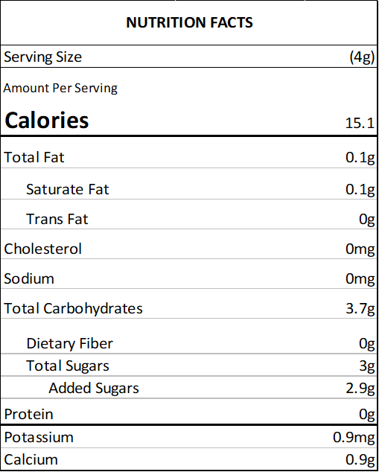

**ALLERGENS**

SOY, MILK, FISH, WHEAT

(This list is not intended to address all substances that may represent an allergen risk to certain individuals.) This product is prepared and packaged using machines that may come into contact with WHEAT, EGGS, MILK, SOY, and TREE NUTS. Unintentional cross contamination can always be a possibility, however remote.

**PACKING**

2 oz Bag (Net Vol. 1/4 Cup) - clear standup barrier pouch

4 oz Bottle (Net Vol. 1/2 Cup) - clear PET plastic jar with white lid

8 oz Bottle (Net Vol. 1 Cup) - clear PET plastic jar with white lid

1 lb Bulk Bag - clear standup barrier pouch

5 lb Bulk Bag - clear standup barrier pouch

10 lb Bulk Bag - corrugated carton containing 1 clear poly bag

**USE**

Decorating cakes, cookies, doughnuts, ice cream, pies and sweets in general.

**STORAGE**

Store in a cool, dry place. Avoid high temperatures, humidity, sunlight exposure, chemicals and strong odors.

**SHELF LIFE**

18 months from the date of manufacture, under the correct storage conditions.

**KOSHER CERTIFICATIONS**

Not certified.

**COUNTRY OF ORIGIN**

United States: decorettes, nonpareils, confetti/quins, wafer paper

Canada: sixlets, candy pearls

Greece: round dragrees