**DESCRIPTION**

Metallic sprinkle mix containing nonpareils, decorettes, candy pearls, sixlets, round dragees, macaroni dragees, and royal icing.

**INGREDIENTS**

Acetic acid, beeswax, calcium stearate, calcium sulfate, carnauba wax, carob, citric acid, cocoa, confectioner's glaze, corn starch, corn syrup, dextrin, dextrose, egg whites (EGGS), gelatin (FISH), glucose powder, glucose syrup, glycerin, gum Arabic, HPMC, hydrogenated palm kernel oil, lecithin (SOY), lutein, magnesium silicate, maltodextrin, mica based pearlescent pigment, palm kernel fat, palm kernel oil, potassium acid tartrate, reduced protein whey (MILK), salt, shellac, silicon dioxide, sugar, tapioca dextrin, tapioca starch, vanilla, wheat starch (WHEAT), xanthan gum, blue 1 (e133), blue 2 (e132), red 3 (e127), red 40 (e129), silver (e174), titanium dioxide (e171), yellow 5 (e102) , yellow 6 (e110), natural and artificial flavors, and less than 1/10th of 1% sodium benzoate and potassium sorbate

**SENSORY SPECIFICATIONS**

Color(s): Burgundy, Pumpkin Spice/Burnt Orange, Goldenrod, Gold, Cream, Mint, Orange, Turquoise, Vintage Gold.

Flavor: Sweet Vanilla

Texture: Crunchy

**NUTRITION FACTS**

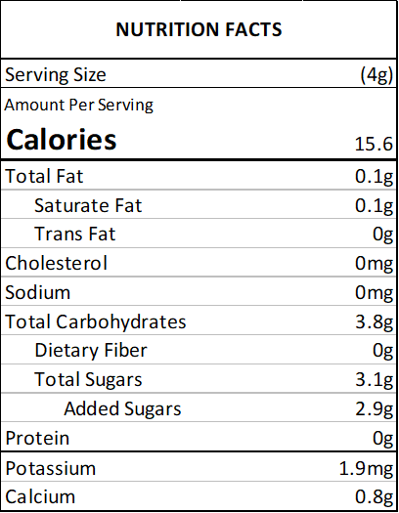

**ALLERGENS**

SOY, MILK, FISH, WHEAT, EGGS

(This list is not intended to address all substances that may represent an allergen risk to certain individuals.) This product is prepared and packaged using machines that may come into contact with WHEAT, EGGS, MILK, SOY, and TREE NUTS. Unintentional cross contamination can always be a possibility, however remote.

**PACKING**

2 oz Bag (Net Vol. 1/4 Cup) - clear standup barrier pouch

4 oz Bottle (Net Vol. 1/2 Cup) - clear PET plastic jar with white lid

8 oz Bottle (Net Vol. 1 Cup) - clear PET plastic jar with white lid

1 lb Bulk Bag - clear standup barrier pouch

5 lb Bulk Bag - clear standup barrier pouch

10 lb Bulk Bag - corrugated carton containing 1 clear poly bag

**USE**

Decorating cakes, cookies, doughnuts, ice cream, pies and sweets in general.

**STORAGE**

Store in a cool, dry place. Avoid high temperatures, humidity, sunlight exposure, chemicals and strong odors.

**SHELF LIFE**

18 months from the date of manufacture, under the correct storage conditions.

**KOSHER CERTIFICATIONS**

Not certified.

**COUNTRY OF ORIGIN**

United States: decorettes, nonpareils, royal icing

Canada: candy pearls, sixlets

Greece: round dragees, macaroni dragees