**DESCRIPTION**

Metallic sprinkle mix containing nonpareils, decorettes, candy pearls, sixlets, crispy round dragees, confetti/quins, and edible glitter.

**INGREDIENTS**

Acetic acid, annatto norbixin, beeswax, calcium stearate, carnauba wax, carob, cellulose gum, citric acid, cocoa, cocoa butter, confectioner's glaze, corn starch, corn syrup, crispy cereal center, dextrin, dextrose, esters of fatty acids, gelatin (FISH), glucose powder, glucose syrup, glycerin, gum Arabic, HPMC, hydrogenated palm kernel oil, lecithin (SOY), lutein, magnesium silicate, malted wheat flour (WHEAT), maltodextrin, mica based pearlescent pigment, propylene glycol, reduced protein whey (MILK), rice flour, salt, sugar, tapioca starch, wheat flour (WHEAT), whole milk powder (MILK), xanthan gum, blue 1 (e133), blue 2 (e132), red 3 (e127), red 40 (e129), silver (e174), titanium dioxide (e171), yellow 5 (e102) , yellow 6 (e110), natural and artificial flavors, and less than 1/10th of 1% sodium benzoate and potassium sorbate

**SENSORY SPECIFICATIONS**

Color(s): Brown, Red, Orange, Yellow, White, Vintage Gold, Gold.

Flavor: Sweet Vanilla

Texture: Crunchy

**NUTRITION FACTS**

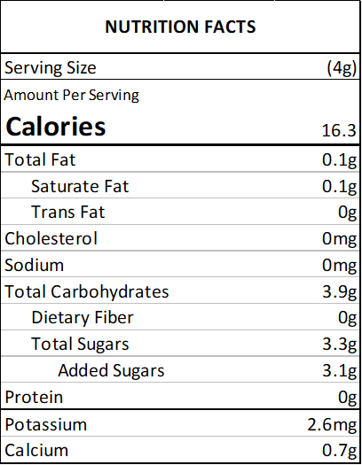

**ALLERGENS**

SOY, MILK, FISH, WHEAT

(This list is not intended to address all substances that may represent an allergen risk to certain individuals.) This product is prepared and packaged using machines that may come into contact with WHEAT, EGGS, MILK, SOY, and TREE NUTS. Unintentional cross contamination can always be a possibility, however remote.

**PACKING**

2 oz Bag (Net Vol. 1/4 Cup) - clear standup barrier pouch

4 oz Bottle (Net Vol. 1/2 Cup) - clear PET plastic jar with white lid

8 oz Bottle (Net Vol. 1 Cup) - clear PET plastic jar with white lid

1 lb Bulk Bag - clear standup barrier pouch

5 lb Bulk Bag - clear standup barrier pouch

10 lb Bulk Bag - corrugated carton containing 1 clear poly bag

**USE**

Decorating cakes, cookies, doughnuts, ice cream, pies and sweets in general.

**STORAGE**

Store in a cool, dry place. Avoid high temperatures, humidity, sunlight exposure, chemicals and strong odors.

**SHELF LIFE**

18 months from the date of manufacture, under the correct storage conditions.

**KOSHER CERTIFICATIONS**

Not certified.

**COUNTRY OF ORIGIN**

United States: decorettes, nonpareils, confetti/quins, edible glitter

Canada: candy pearls, sixlets

Greece: crispy round dragees